Your First Program with C++

To create the first program, you will need to open text editor—Notepad and type the following C++ code:  
  
#include<iostream>  
using namespace std;  
  
int main()  
{  
   cout << "Hello World\n";  
   return 0;  
}

In Dev-C++ editor, to develop the C++ program, you will follow the steps below.

-Go to File menu, select New. Then select Project...

-On the new project window, select Console Applicaiton and enter the name of the project in the Name text box. Then click OK to create the project.

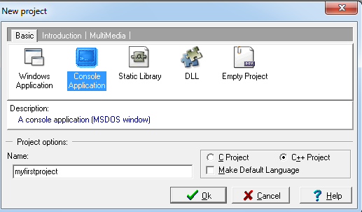

- It will prompt you to the save the project. Please save the project. Then you will get the code block as shown below.  
#include <iostream>

using namespace std;

int main()  
{

   system("PAUSE");  
   return EXIT_SUCCESS;  
}

-You won't need to remove this existring code block. Simply you will write the line of code: cout << "Hello World\n"; above the system("PAUSE"); statement.